Hi All,

Just providing a few resources to help everyone wrap their heads around what we’re trying to achieve with the biotech AI agent ops project, and how that might impact drug development at biotechs companies and the drugs they produce for society. I know we didn’t finalize the decision to go with the biotech-focused project, but in the event that we proceed down this route, I wanted to give some background of biotech because I know not all of you have worked in this industry.

**Our Starting Point:**

**The Multi-Agent System**

In our first Omdena collaborator meeting, we discussed creating a “multi-agent system” with one RouterAgent and 4 downstream DomainAgents. A DomainAgent is just an agent that specializes in one knowledge domain, like chemistry for example (ChemAgent). I had already started building a system like this, which I call the **TechBio C-Suite CoPilot**, and the purpose of it is to help biotech CXOs answer challenging business questions that involve multiple knowledge domains like chemistry, biology, the biotech market and investor landscape. Even CEOs can’t keep all this domain info in their heads!

I’ve created a schematic below of how the information would initially flow in this multi-agent system as a starting point for understanding how it could work.

**Initial Flow (Only) of Info in the Multi-Agent System:**

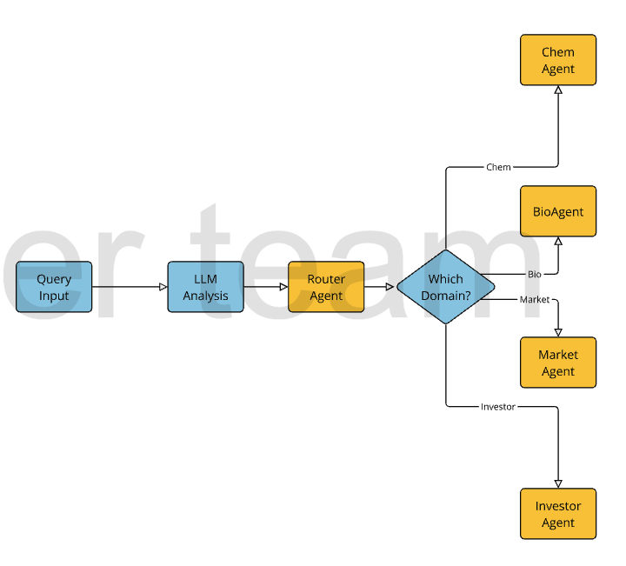

The AI Ops Component:

*I’m not very knowledgeable on this topic, so I’ll let someone else comment in here.*

**Trends in Biotech R&D Today**

Biotech R&D is a complex ecosystem that involves discovery, preclinical research, clinical trials, and regulatory approvals. Traditionally, this process has been both time-consuming and resource-intensive, often dependent on manual oversight and fragmented data. This is where our project comes in—we’re looking to streamline these processes, enhance oversight, and ultimately help accelerate the development of safer, more effective drugs.

**Introducing AI Agent Ops**

At its core, AI Agent Ops leverages intelligent agents to handle routine tasks, analyze data in real-time, and monitor ongoing R&D activities. Imagine having a team of virtual assistants that work 24/7 to:

* Aggregate and process data: From lab results to clinical trial outcomes, AI agents can quickly sift through vast amounts of data to identify trends and flag potential issues.
* Ensure regulatory compliance: By continuously monitoring the adherence to protocols and regulations, these agents can alert teams before small issues become big problems.
* Enhance decision-making: With predictive analytics and real-time insights, decision-makers can better assess risks and opportunities, speeding up the R&D pipeline without compromising safety or quality.

**Why It Matters for Society**

The implications of integrating AI Agent Ops into biotech R&D are profound. For one, faster and more reliable drug development can translate into quicker access to innovative treatments for patients. Additionally, improved oversight means a higher standard of safety and efficacy in the drugs that eventually hit the market. In a world where public trust in scientific advancements is crucial, our project has the potential to set a new benchmark for transparency and accountability in R&D.

**Resources - Case Studies with AI Agent Ops**

1. IT Operations and Incident Management

A standout example is IBM’s implementation of Watson AIOps in IT operations. This case study showcases how AI-driven agents can monitor vast IT infrastructures, detect anomalies in real time, and even predict incidents before they cause disruptions. By automating root-cause analysis and streamlining incident management, companies have seen a significant reduction in downtime and operational costs. You can explore the full details on IBM’s website: [IBM Watson AIOps](https://www.ibm.com/cloud/watson-aiops).

2. Manufacturing and Predictive Maintenance

In the manufacturing sector, companies like Siemens have leveraged AI for predictive maintenance. Their case studies demonstrate how AI agents analyze sensor data from equipment to predict failures and schedule maintenance proactively. This not only reduces downtime but also improves overall production efficiency. Check out Siemens’ insights and case examples here: [Siemens Predictive Maintenance](https://new.siemens.com/global/en/products/services/digital-services/predictive-maintenance.html).

3. Financial Services and Risk Management

Another compelling case comes from the financial industry, where institutions have adopted AI agent operations for real-time risk assessment and fraud detection. For instance, JP Morgan has integrated AI systems that continuously analyze transaction patterns to flag suspicious activities instantly, thereby minimizing risk exposure. Detailed insights and case studies can be found on JP Morgan’s innovation blog: [JP Morgan AI in Risk Management](https://www.jpmorgan.com/insights/technology).

Go ahead and feel free to check out these materials and think about how your expertise can help us push the boundaries of what’s possible. Our goal is to not only enhance R&D processes and their oversight of drug development but also to ensure that these innovations benefit society as a whole.

=====================

Notes From the AI Ops Video:

**“Effective AIOps with Open Source Software in a Week” - Webinar Video by Databricks**

AI AgentOps

* Need to be able to monitor mission-critical systems that use AI Agents

Basing this project on the Databricks AI Ops webinar, we can use the following tools:

* Apache Flink (distributed stream processing framework)
* Python Keras (DL framework)
* MySQL Database (for maintaining the data)
* Grafana (Observability platform)
* Prometheus Monitoring & Time Series Database (Optional)

AI Ops and Operational Events and Data

* Logs
* Traces
* Alerts
* Configuration Management
* Reference and Lookup Details
* Summarized Metrics

Prior to AI Ops, most data collected was on logs and events, but that changed with AIOps Open Architecture that was outlined in the video.

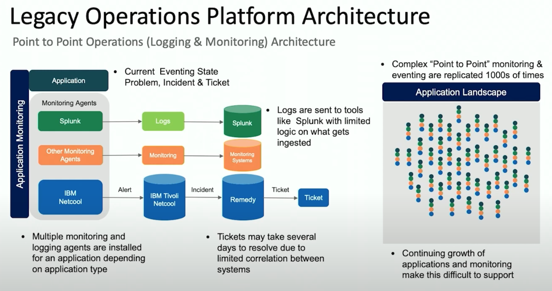

New AI Ops Architecture

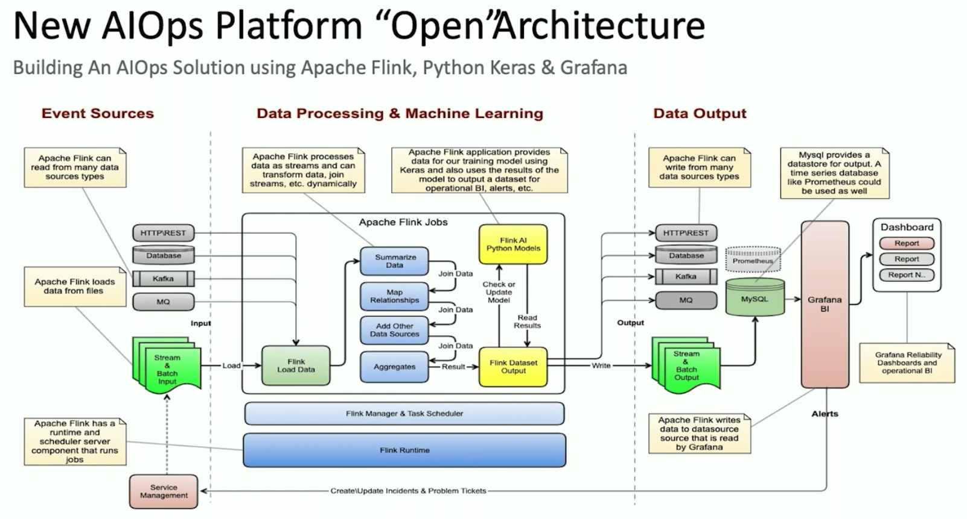

* They used Grafana as the “Operational Business Intelligence” to analyze all the logs and events that were ingested into a MySQL database.

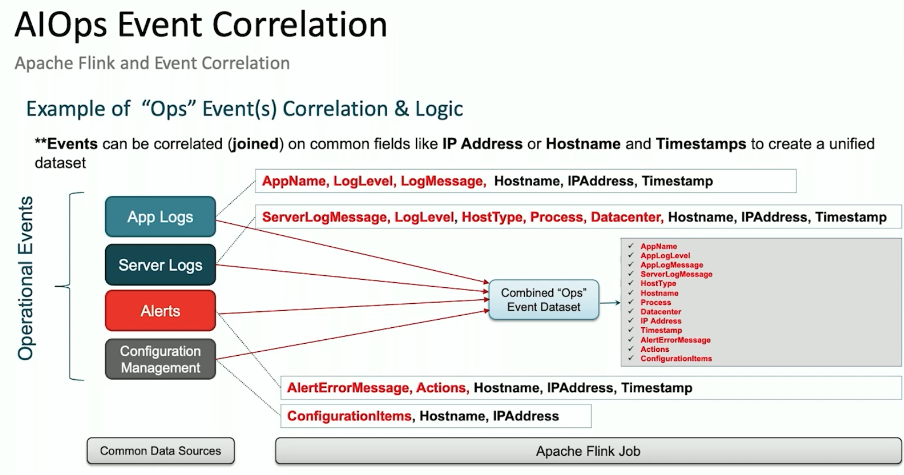

The general goal is to set yourself up to do Predictive Analytics and Modeling

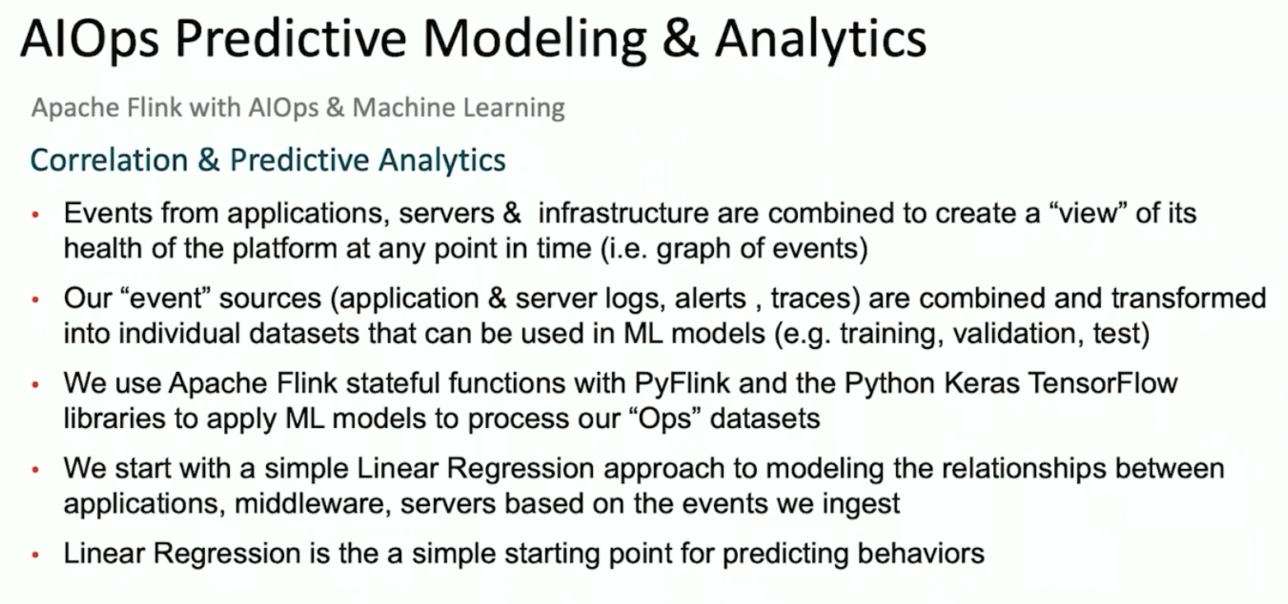

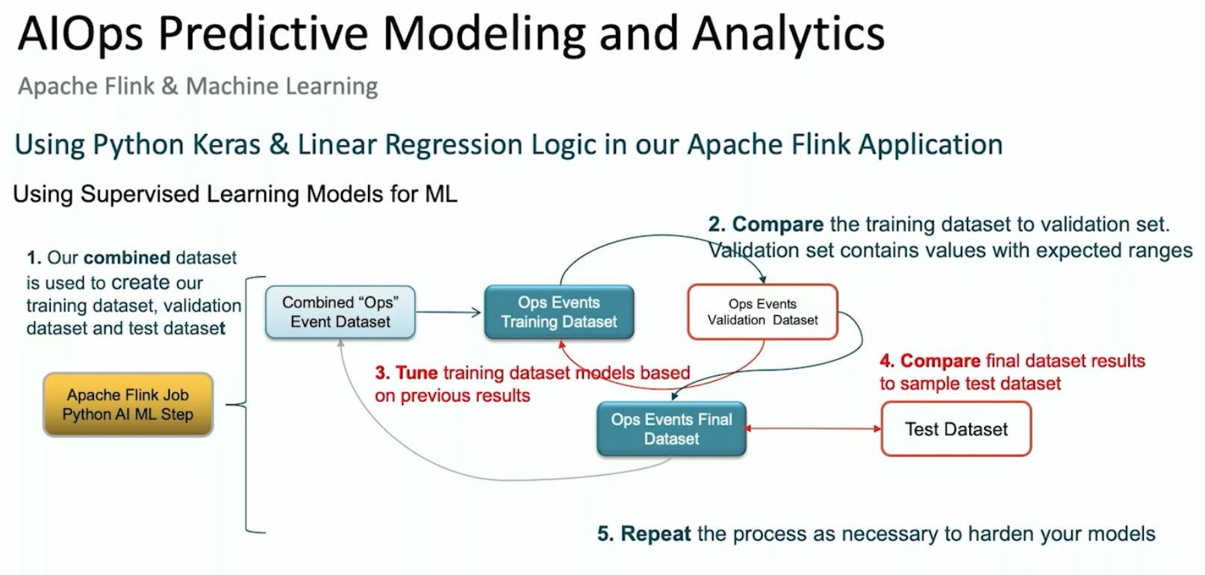

They used Grafana for visualizations and analysis of the metrics that they were tracking.

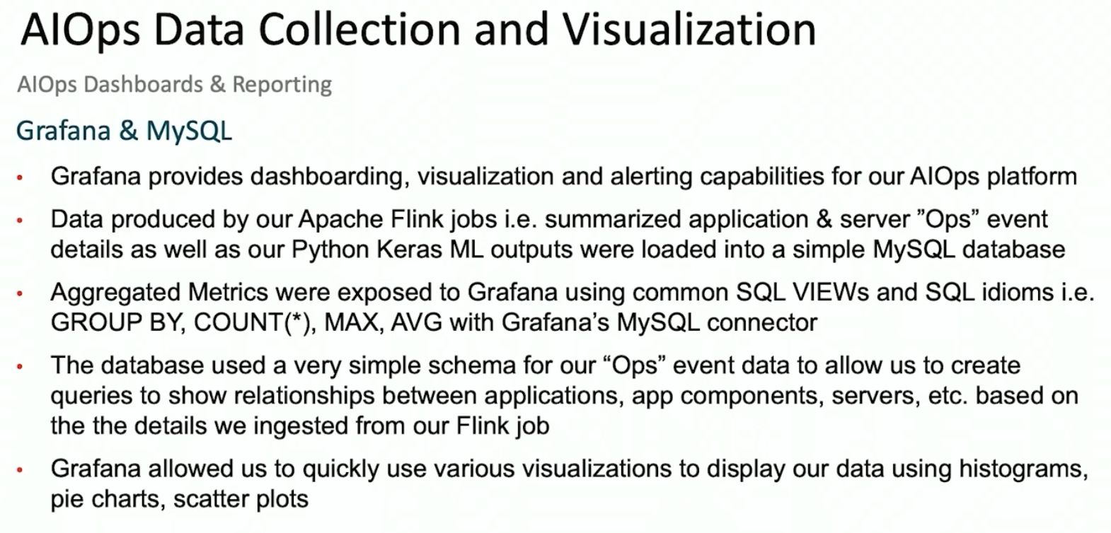

(It basically just used 5 tables of data).

They created a high-level dashboard to highlight incidents per data center.

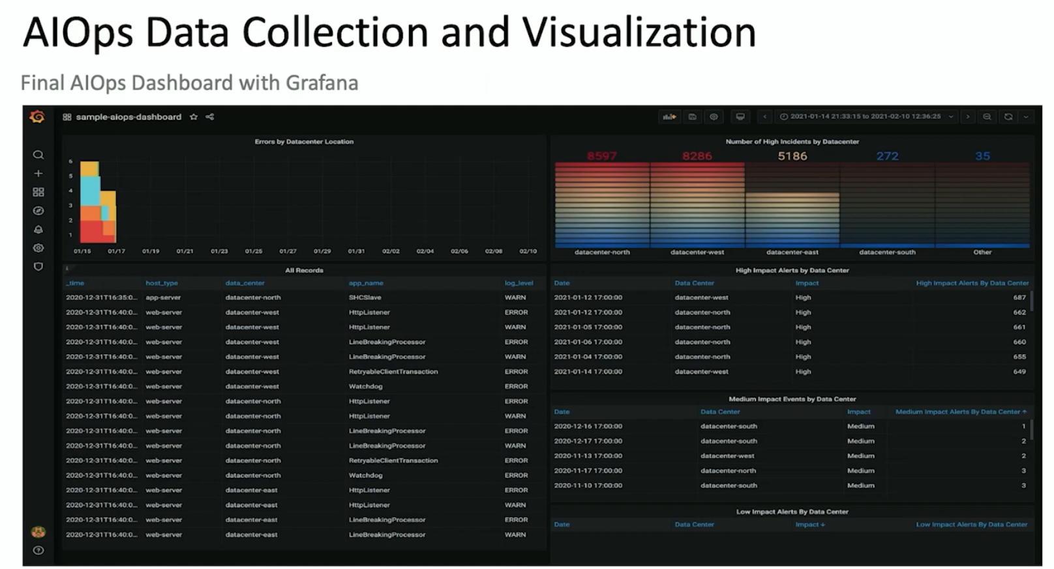

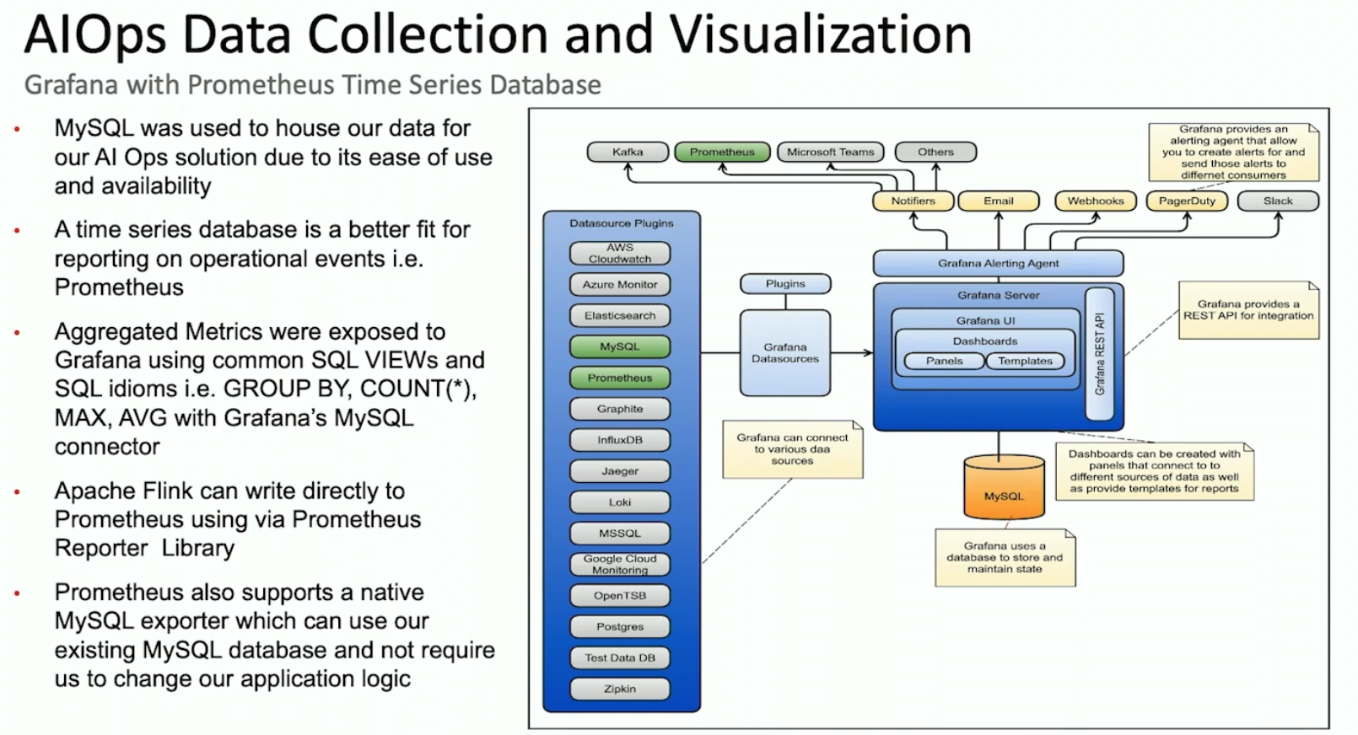

**For production envirnments, it’s best to use Prometheus, not MySQL

